EE463 Hardware Project
Joshua James Ramsey
Kerim Çağrı Şen
Muhammed Yusuf Kazan

Introduction
In this project, the aim is to create an AC to DC converter that can run the DC machine at rated voltage and rotation speed for at least 2 minutes. The inductor current ripple frequency must be greater than 1kHz. The following topologies were considered:
Single-Phase Full Bridge Rectifier + Buck Converter: Simple topology. Uses fewer and readily available components. Requires large capacitor to smoothen the large ripple created by the rectifier stage.
Three-Phase Full Bridge Rectifier + Buck Converter: Comparatively lower voltage ripple while still having a relatively simple topology.
Three-Phase Thyristor Rectifier: Simpler topology, high power capability. High voltage thyristors are less affordable. The circuit requires more complex control to prevent issues and failure.
In the end, we decided to stick to three-phase full bridge rectifier + buck converter to have a smoother ripple. We utilized the topology in the “chopper” form, where the inductor and output capacitor are not present. We have chosen our switching frequency to be 5kHz.
Design Decisions
Placeholder – waiting for partner
Computer Simulations
Placeholder – waiting for partner
Component Selection
Placeholder – waiting for partner
Test Results
Before the results are presented, due to the health concerns caused by the solder smoke and the tightness of the schedule, we decided not to implement the control loop. We settled with just implementing a gate driver, utilizing an isolator to make sure Arduino is safe from any possible circuit faults. The final circuit diagram is in Figure 1.
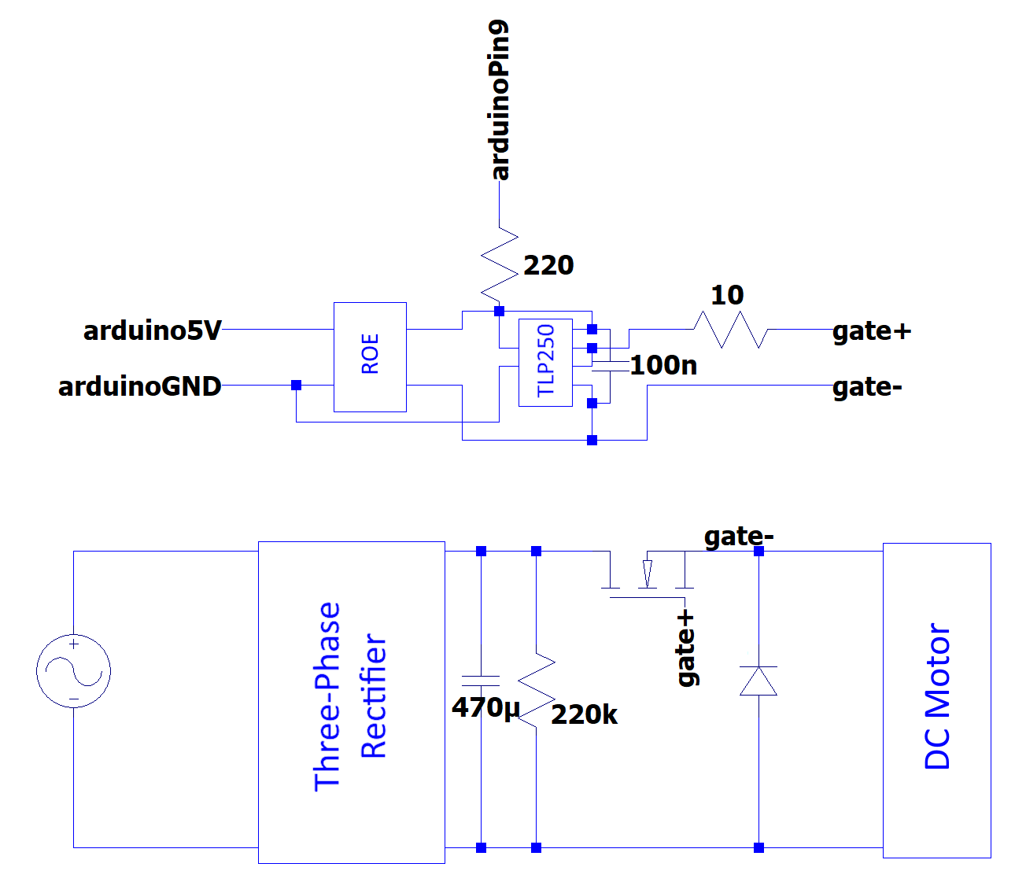
Figure 1. The final circuit diagram.
The physical circuit is given in Figure 2.
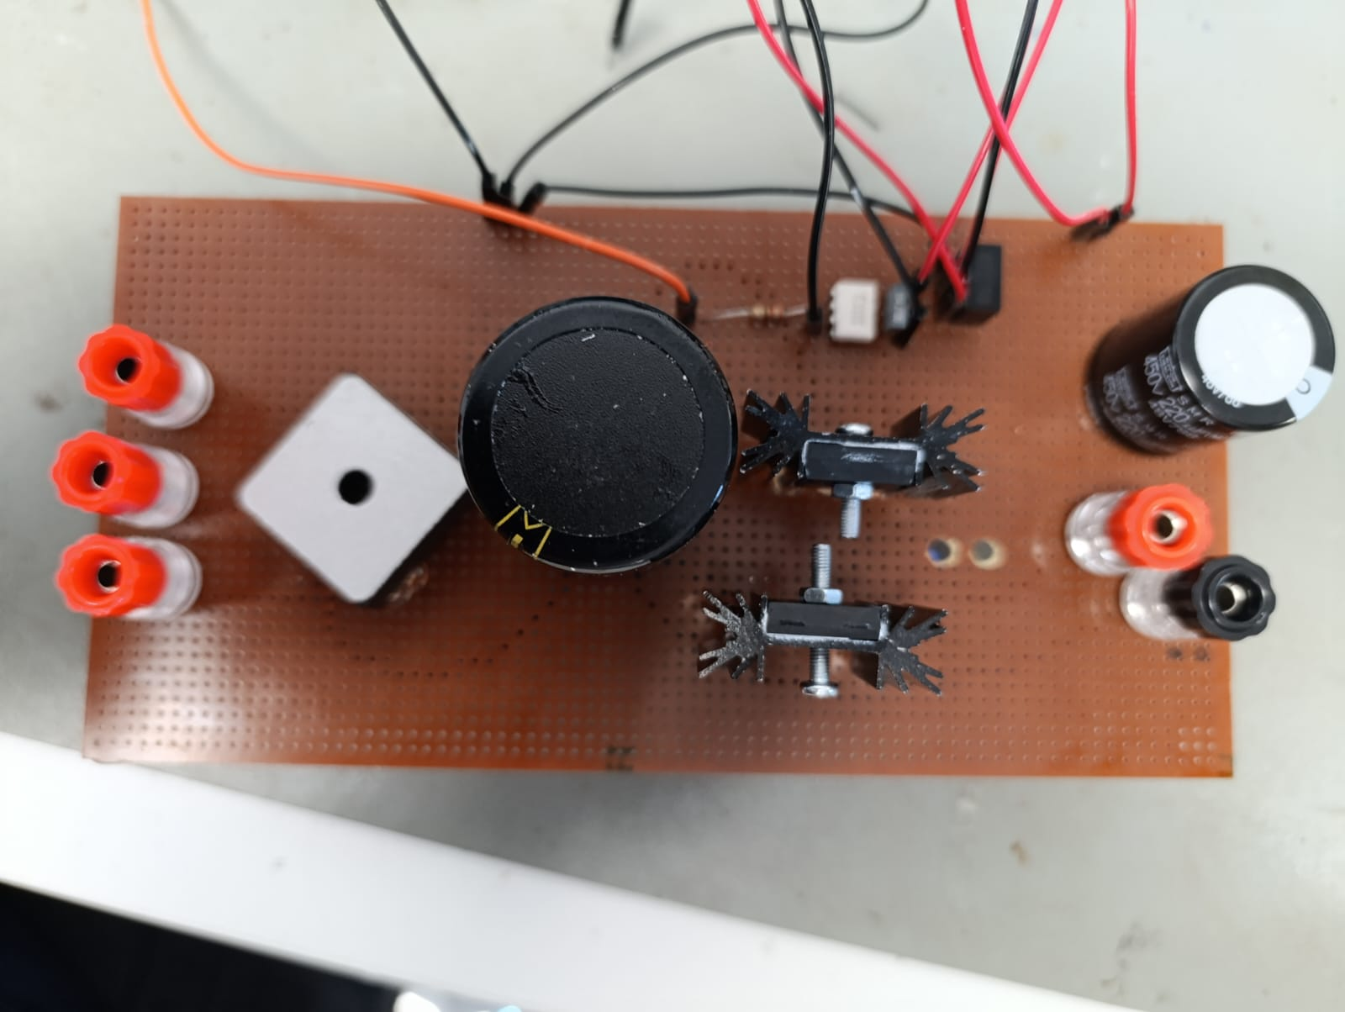
Figure 2. The physical circuit.

Note that there is an output capacitor in this implementation. We ended up cutting the wires under the stripboard to disconnect it from the circuit, but for health reasons, we did not want to desolder it.
We first performed tests with R and RL loads. Figure 3 is for the R load, and Figure 4 is for the RL load. The yellow waveform (CH1) is the output voltage, the light blue waveform (CH2) is the output current, and the pink waveform (CH3) is the switching voltage.
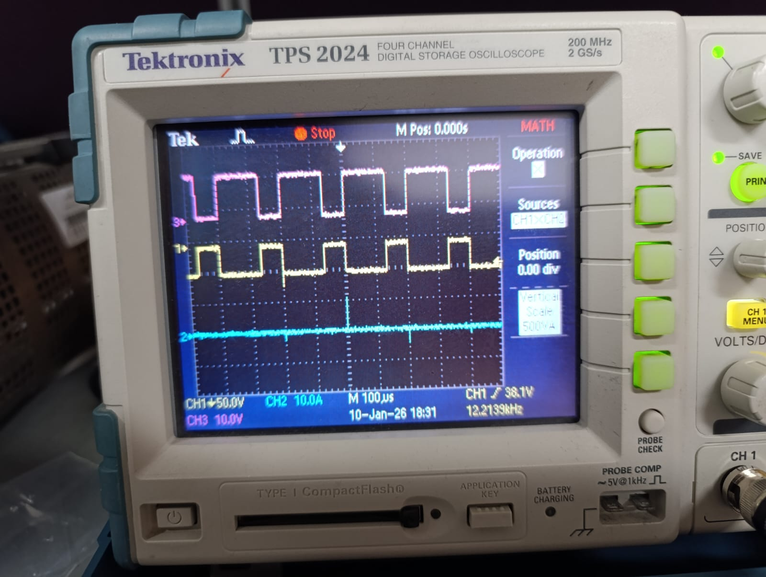
Figure 3. R load test with R approximately 4.9Ω.
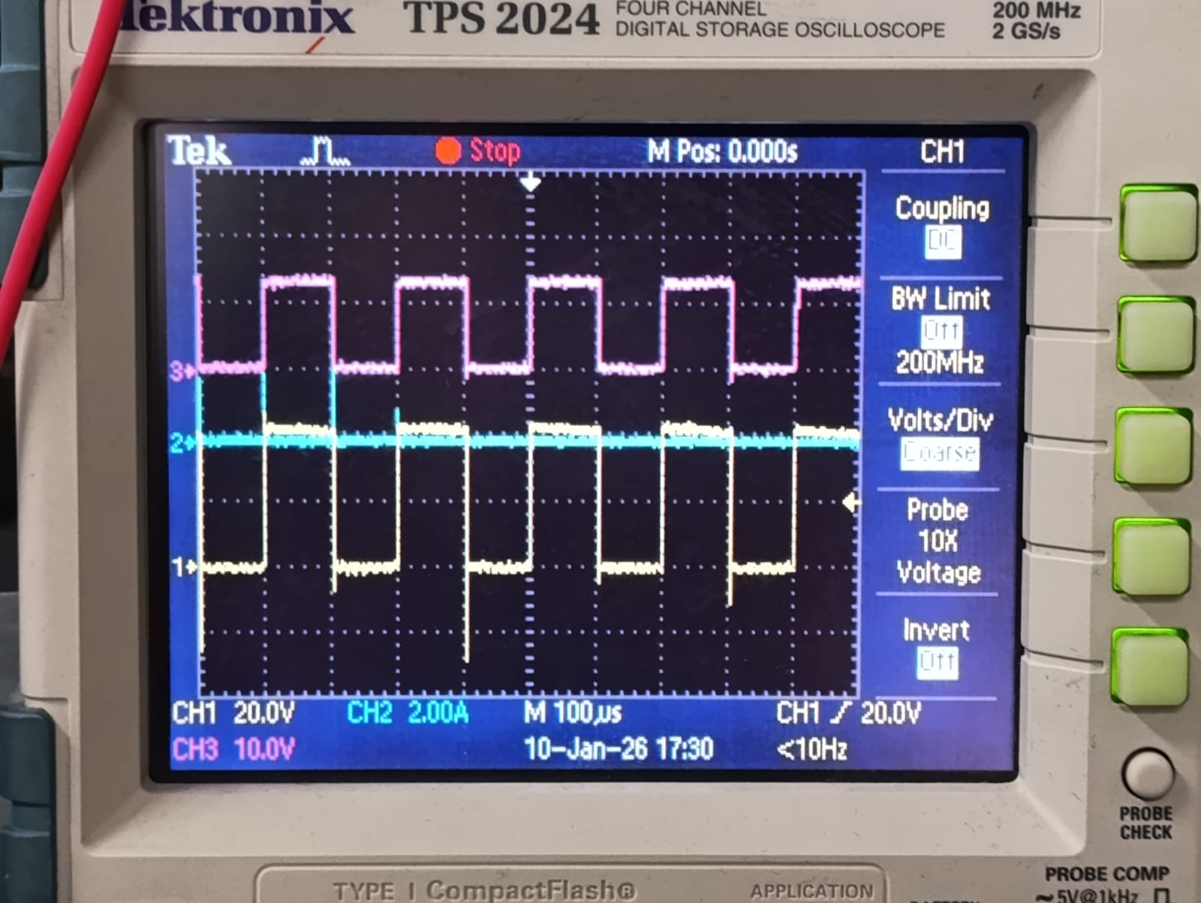
Figure 4. RL load test with R approximately 27Ω, L approximately 50mH.
We did not do any high voltage tests since we were afraid we could burn the circuit and have nothing to show during the demonstration day.
We initially wanted to control our duty cycle actively from Simulink. Unfortunately, our Arduino would keep disconnecting from the computer in terms of communication, and the model would no longer be able to update the duty cycle. This is most likely caused by the noise in the circuit. Because of this, we instead settled with a Simulink model that does not require any communication once uploaded into the Arduino. When we did this, we were able to drive the motor almost effectively. Our average voltage output kept fluctuating between 170V and 190V, instead of hanging around 180V. In the demo, we were able to run the motor at rated voltage as well as run the kettle for 5 minutes. During the operation, the hottest component was our three-phase rectifier, which is to be expected. It did not have any heat sink on it. It reached up to 85°C. Figure 5 shows the heatmap during operation.
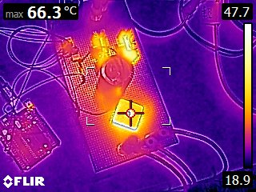
Figure 5. Heat map of our circuit.
In the end, our circuit did not blow up, and we were able to perform the tea bonus, as well as the single supply bonus.
Conclusion
In conclusion, we managed to design a circuit that was able to run the DC motor at the rated voltage and speed without blowing up. For us, the most critical parts were soldering carefully and selecting components with proper rating. The former required us to keep the thick cables far apart from each other to take precautions against high-voltage arcing. Due to unexpected health concerns and time struggles, we had to abandon closed-loop implementation. Our circuit did not fail, but we had fluctuation on the output voltage average even though the output was a proper square wave. This may have been due to the noise in the drivers, causing the duty cycle to change slightly. Nonetheless, it was a valuable experience for us as it showed us the importance of safety considerations and possible parasitics, affecting the communication between digital components.

